4 DECEMBER 2023

New data reveals Yorkshire and Humber as hotspot for children hit by two-child limit on benefits
- Yorkshire and Humber among regions with the highest percentage of households hit by the two-child limit
- 13% of children in Yorkshire and Humber impacted
- 12 of the 20 UK local authority areas with the highest percentage of affected families are in the North of England.
Children in Yorkshire and the Humber are more likely to be hit by the two-child limit on benefits than in almost any other region in the UK, new data reveals.

Yorkshire and the Humber (13%), The West Midlands (14%) and the North West (13%) have the highest percentage of households affected by the two-child limit across the UK. The data also reveals a strong correlation between the two-child limit and areas with high rates of child poverty.

New local data obtained by the End Child Poverty Coalition, of which the National Education Union is a steering group member, shows that 12 of the 20 UK local authority areas with the highest percentage of affected families are in the North of England. 4 of the 20 Parliamentary constituencies with the highest percentage of affected families are in Yorkshire and Humber.

The two-child limit affects families entitled to benefits who have had a third or subsequent child after 6 April 2017. These parents are denied £3,235 per year per child compared with families who have a third or subsequent child born before that date.

Research suggests that scrapping the two-child limit is one of the most cost-effective ways of addressing child poverty. Ending the policy would lift 250,000 children out of poverty at a cost of £1.3bn (1).

The local authorities in the region with the highest percentage of children living in households affected by the limit are Bradford, at 17%, and the City of Kingston Upon Hull, at 16%. In North East Lincolnshire the figure is 15%, and in Doncaster it is 14%.

There are around 1.5 million children in the UK living in households subject to the two-child limit on benefit payments – equivalent to one in 10 (2). Areas most affected by the two-child limit are those with the highest child poverty rates.

Research has shown that the two-child limit has limited impact (4) on increasing the number of parents who enter employment. In fact, the majority (58%) of families affected by the policy are already in work (5).

Kate Harr, NEU Regional Secretary for Yorkshire and Humber, said:

“The two-child limit is having a disproportionate effect on families in Yorkshire and Humber, with this new research indicating that 150,920 children in our region are directly impacted by this policy. It’s not right that children with two or more siblings are more likely to be growing up in poverty.
“Child poverty is a growing crisis in our schools and in our communities and our members are seeing it’s effects first hand, with children attending school hungry and without sufficient warm winter clothing. Abolishing the 2-child limit would immediately lift 250,000 children out of poverty across the country and help our children to thrive and learn.”

Joseph Howes, Chair of the End Child Poverty Coalition and CEO of Buttle UK said:

“Imagine saying to a child who turned up at school – sorry you can’t gain access, we won’t fund your education – only your two older siblings qualify. Or turning a child away from hospital when they need treatment, as they are the third child in a family. Yet this is exactly what the unfair two-child limit to benefit payments does, it denies families the support they need, at a time when they need it the most.

“As a parent I want to be able to provide for my children, especially at a magical time like Christmas. But we know from speaking with families impacted by the two-child limit that this time of year is anything but joyful. Instead, they worry about heating their homes, and providing even basic food over the Christmas period.

“If political parties seriously want to tackle child poverty, they need to start by scrapping the two-child limit to benefit payments.”

Ends.

Notes to editor:

English regions ranked by percentage of children affected by two child limit.

English region | Number of children affected by 2CL | % of children affected by 2CL | Local child poverty rates 21/22
West Midlands | 183030 | 14% | 38%
North West | 208680 | 13% | 34%
Yorkshire and the Humber | 150920 | 13% | 31%
North East | 65460 | 12% | 35%
London | 231470 | 11% | 33%
East Midlands | 109630 | 11% | 33%
East of England | 125810 | 9% | 24%
South West | 97530 | 9% | 27%
South East | 162550 | 8% | 25%

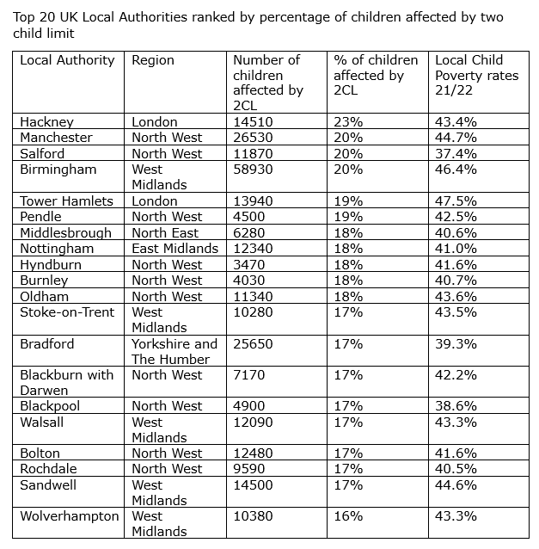
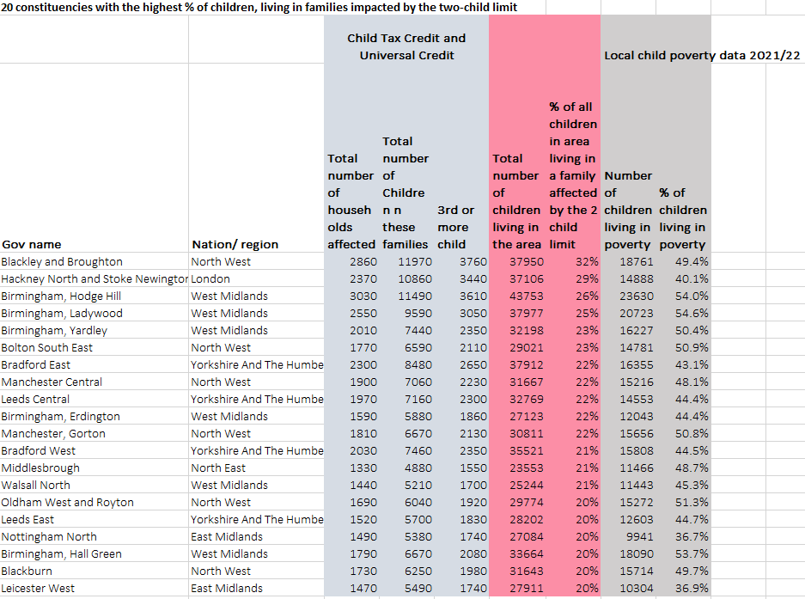

About the data

The data on the two-child limit was obtained via Freedom of Information requests to the Department of Work and Pensions, HMRC and the Department for Communities Northern Ireland. You can download the full spreadsheet of data here: https://endchildpoverty.org.uk/

The Local Child Poverty data is calculated each year by Loughborough University, for the End Child Poverty Coalition, and can be found here: https://endchildpoverty.org.uk/child-poverty/.

References:

1 – Child Poverty Action Group, Budget submission 2023, 2023
2 – From Universal Credit and Child Tax Credit claimants: statistics related to the policy to provide support for a maximum of 2 children, April 2022: https://www.gov.uk/government/statistics/universal-credit-and-child-tax-credit-claimants-statistics-related-to-the-policy-to-provide-support-for-a-maximum-of-2-children-april-2022/universal-credit-and-child-tax-credit-claimants-statistics-related-to-the-policy-to-provide-support-for-a-maximum-of-2-children-april-2022#main-stories
3 – The Local Child Poverty data is calculated each year by Loughborough University, for the End Child Poverty Coalition, and can be found here: https://endchildpoverty.org.uk/child-poverty/.
4 – From Benefit Changes & Larger families, 2022: https://largerfamilies.study/publications/the-two-child-limit-and-choices-over-family-size/
5 – From Universal Credit and Child Tax Credit claimants: statistics related to the policy to provide support for a maximum of 2 children, April 2022: https://www.gov.uk/government/statistics/universal-credit-and-child-tax-credit-claimants-statistics-related-to-the-policy-to-provide-support-for-a-maximum-of-2-children-april-2022/universal-credit-and-child-tax-credit-claimants-statistics-related-to-the-policy-to-provide-support-for-a-maximum-of-2-children-april-2022#overall-numbers-of-households-affected-by-the-policy-to-provide-support-for-a-maximum-of-two-children

About the End Child Poverty Coalition

The End Child Poverty Coalition is made up of over 100 organisations including child welfare groups, social justice groups, faith groups, trade unions and others. Together with a group of Youth Ambassadors we all believe that no child growing up in the UK should live in poverty.
Together we ask that this and future governments commit to end child poverty.

About the NEU

The National Education Union (NEU) brings together the voices of more than 450,000 teachers, lecturers, support staff and leaders working in maintained and independent schools and colleges across the UK, to form the largest education union in Europe.

Media contact

Kate Harr, NEU Yorkshire and Humber Regional Secretary, 07453074941, kate.harr@neu.org.uk.

Interviews available with Kate Harr.

Caroline Cowie, Senior Media Relations Officer
Caroline.Cowie@neu.org.uk
0207 380 4707

