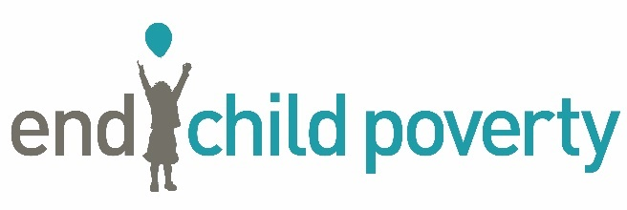
MEDIA RELEASE
Embargoed until: 00:01 Wednesday 19th May 2021
Contact: Richard Newson / rnewson@ncb.org.uk / media@ncb.org.uk 07721 097 033

A THIRD OF CHILDREN NOW LIVING IN POVERTY IN SOME PARTS OF THE SOUTH WEST
- Local authority and Constituency data is available on request or from Wednesday at https://www.endchildpoverty.org.uk/
The End Child Poverty coalition has today published figures providing a new Child Poverty map of the UK. The new figures estimate that there are now parts of the South West where a third of children are growing up in poverty - compared to one in seven, in areas in the country with the lowest child poverty rates.
Although child poverty in the South West is not as high as other areas in the UK - for the whole of the South West 26% of children live in poverty after housing costs are factored in - there are still places where significant numbers of children live below the poverty line. The parts of the South West with the highest percentage of children living in poverty include:
- Bristol – 33.5% of children living in poverty (a total of 28,800 children) in 2020 – a rise of 3.4 percentage points between 2015 and 2020.
- Torridge – 32.4% of children living in poverty (a total of 3,540 children) in 2020 – a rise of 2.5 percentage points between 2015 and 2020.
- Cornwall – 30.8% of children living in poverty (a total of 29,760 children) in 2020 – a rise of 1.7 percentage points between 2015 and 2020.
- Torbay - 30% of children living in poverty (a total of 6,840 children) in 2020 – a rise of 1.2 percentage points between 2015 and 2020.
- Plymouth - 29.8% of children living in poverty (a total of 14,170 children) in 2020 – a rise of 0.7 percentage points between 2015 and 2020.
It is estimated that over a quarter of a million children in the South West are living in poverty (or 26%) after housing costs are factored in to Government data.
As the pandemic risks pushing ever larger numbers of children below the poverty line, the End Child Poverty coalition is calling on the Chancellor to make the uplift in Universal Credit benefits permanent – rather than remove it at the end of the summer.

Anna Feuchtwang, Chief Executive of the National Children’s Bureau said:
“Poverty can hold children back in many different ways. It can mean children don’t reach a good level of health or development, do well in school or reach their potential in employment.
“The Government has pledged to level up communities worst hit by poverty. Boris Johnson must acknowledge that there are pockets of deprivation where children are growing up in families that can barely afford the basic necessities of life. Levelling up must address this across the length and breadth of the country not just in certain areas.”
ENDS

Notes to editors:

Contact: Richard Newson / rnewson@ncb.org.uk / media@ncb.org.uk / 07721 097 033
- Percentage point increases. It is important to refer to the increases as percentage point increases, not as percentage increases. For example: 50 children in poverty out of 100 is a rate of 50% child poverty. If, the following year, there are 10 more children in poverty (a 20% increase), that means there are now 60 children in poverty. A rate of 60% up from 50%: a 10 percentage point increase.

- The research was carried out by Dr Juliet Stone and Professor Donald Hirsch at the Centre for Research in Social Policy, at Loughborough University based on the latest Before Housing Cost child poverty data from DWP published in March 2021.

- Report and data all available from Wednesday 19th May at Local child poverty data 2014/15 - 2019/20 | Improving the lives of children and families (endchildpoverty.org.uk)

- For a family of one adult and one child, 60% of median income, after housing costs, in 2019/20 was £223 week

  - For a family of one adult and two children, £280 week
  - For a family of two adults and one child, £343 week
  - For a family of two adults and two children, £400 week

About End Child Poverty
End Child Poverty is a coalition of organisations from civic society including children’s charities, child welfare organisations, social justice groups, faith groups, trade unions and others, united in our vision of a UK free of child poverty. ECP is chaired by the National Children’s Bureau. For more details visit www.endchildoverty.org.uk / www.ncb.org.uk

